**[ MUSA Council AGENDA ]**

Date: 09/25/24

Time: 8:00AM

Location: MUSA Office

1. **Attendance**

| **Name** | **Position** | **Attendance** |
| --- | --- | --- |
| Emma Porter | President |  |
| Sayako Leznoff | Interim VP Finance |  |
| Jobert Leong | VP Admin |  |
| Denise Chung | VP Internal |  |
|  | VP External |  |
|  | VP Student Resource |  |
|  | 4th Year Representative |  |
|  | 3rd Year Representative |  |
|  | 2nd Year Representative |  |
|  | 1st Year Representative |  |

1. **Call to Order**

The meeting was called to order at PDT

1. **Land Acknowledgement**

acknowledged that UBC’s Vancouver Point Grey campus is situated on the traditional, ancestral, unceded territory of the hən̓q̓əmin̓əm̓-speaking xʷməθkʷəy̓əm (Musqueam) people. The MUSA Council would also like to acknowledge that everyone is located in many places, near and far, and acknowledge the traditional owners and caretakers of those lands.

1. **Amendments to the Agenda**

1. **Adoption of the Agenda**

MOVED BY , SECONDED BY .

“BE IT RESOLVED THAT the agenda be adopted as ________.”

Result:

1. **Approval of Previous Meeting Minutes**

MOVED BY , SECONDED BY .

“BE IT RESOLVED THAT the meeting minutes of be adopted as _________.”

Result:

| **VII. Agenda Items** | **VIII. Action Items** |
| --- | --- |
| Reps for different councils | |
| * The students need to elect a rep to sit on the council that selects the new Music Director * Rep that we share with VSE and School of Social Work on ARTS council? |  |
| Elections | |
| * Do we know if there are students running for every position |  |
| Retreat | |
| * Ropes course is $500 if we have less than 15 people, need to find another retreat option |  |
| Truth and Reconciliation | |
| * Who will be there? |  |
| October FBF | |
| * Order from Tims   + 2 carafes of coffee, 4 boxes of donuts   + Emma will run the table |  |
| October Movie Night | |
| * Inside Out 2 will be on disney+ and since it is our group costume, could be good to also have as our movie |  |
|  |  |
| - | - |

1. **Adjournment**

“BE IT RESOLVED THAT there being no further business the meeting be adjourned at .”

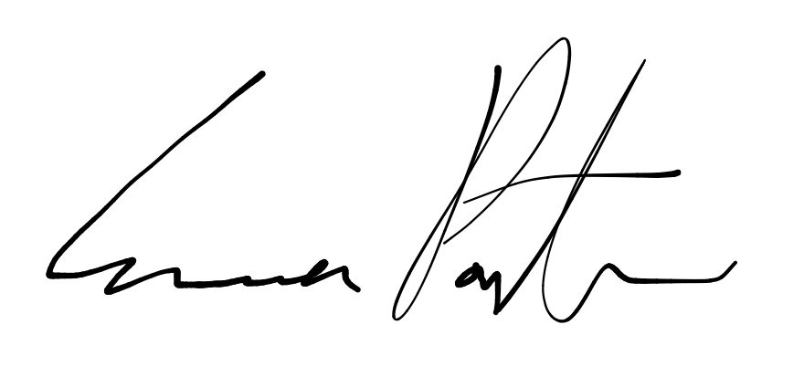

___________________________

**Emma Porter**

President

UBC Music Undergraduate Students’ Association

Respectfully submitted by

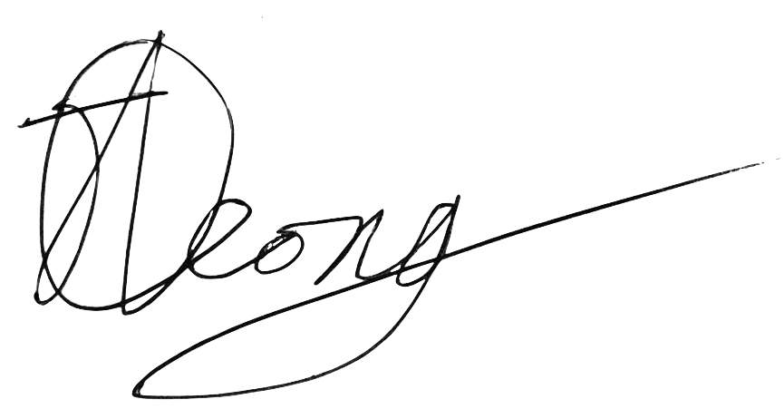

**Jobert Leong**

Vice President of Administration

UBC Music Undergraduate Students’ Association