**[ MUSA Council AGENDA ]**

Date: 11/20/24

Time: 8:00am

Location: MUSA Office

1. **Attendance**

| **Name** | **Position** | **Attendance** |
| --- | --- | --- |
| Emma Porter | President | P |
| Sayako Leznoff | VP Finance | P |
| Jobert Leong | VP Admin | P |
| Denise Chung | VP Internal | P |
| Deanicka Loy Sales | VP External | P |
| Mayvelee Bugh | VP Student Resource | P |
| Maryam Khamis | 4th Year Representative | P |
| Matthew Lew | 3rd Year Representative | P |
| Jalen Logan | 2nd Year Representative | P |
| Zaiden Grayda-Reyes | 1st Year Representative | P |

1. **Call to Order**

The meeting was called to order at 8:05am PDT

1. **Land Acknowledgement**

Emma acknowledged that UBC’s Vancouver Point Grey campus is situated on the traditional, ancestral, unceded territory of the hən̓q̓əmin̓əm̓-speaking xʷməθkʷəy̓əm (Musqueam) people. The MUSA Council would also like to acknowledge that everyone is located in many places, near and far, and acknowledge the traditional owners and caretakers of those lands.

1. **Amendments to the Agenda**

* Grad photos deadline

1. **Adoption of the Agenda**

MOVED BY JJ, SECONDED BY Matty.

“BE IT RESOLVED THAT the agenda be adopted as amended.”

Result: amended

1. **Approval of Previous Meeting Minutes**

MOVED BY Saya, SECONDED BY Maryam.

“BE IT RESOLVED THAT the meeting minutes of 11/06/24 be adopted as approved.”

Result: approved

| **VII. Agenda Items** | **VIII. Action Items** |
| --- | --- |
| **Colouring Event** | |
| * Tomorrow, 12pm-3pm, Room 462 * Today is the last day to put colouring pages into the drive   + **Emma** will be printing tomorrow morning * Snacks and pencil crayon purchase update? * Please make sure to spread the word   + Post to social media   + Year reps, make sure to send to the other students in your year | * **Saya** will bring pencil crayons and snacks * **Emma** will be printing colouring sheets tomorrow morning |
| **Mental Health Initiative - Prof. Raftery** | |
| * Prof Rafftery is hosting an mental health event in Barnett with refreshments   + Mental wellness/anxiety workshop * He has asked musa to make a poster and help him spread the word | * **Denise** will post on Instagram once we have more info * **Mayvelee** will send out information in an email as well |
| **First Year Interfaculty Event** | |
| * **Zaiden**: Trying to decide between interfaculty week (booths for each faculty), gala (in the Pit), worrying about turnout, gala more popular among Council * **Emma**: What’s money going towards (AMS venues are free) | * **Zaiden** will report back with results about event decision once details are confirmed |
| **Retreat** | |
| * The day/time that the most of us are free is Monday, Nov 25, 9pm * <https://www.ams.ubc.ca/wp-content/uploads/2024/08/Gal-MenuFinalV3-August-2024.pdf> * <https://www.koerners.ca/menu> * <https://crafthouse.xdineapp.com/consumer#viewMenu/4675/UBC/617993/DINE%20IN%20MENU> * Decided on pushing it back | * **Emma** will make another When2meet for a new date |
| **Social Media** | |
| * **Zaiden** takes over instagram tomorrow!   + Will need to get the password from **Denise** * Thank you to **Deanicka** for all your help with the website! It looks great * There are a couple of reels in the drive to promo events and concerts   + Should we film some reels today to invite people to the colouring event | * **Zaiden** takes over instagram tomorrow (Will need to get the password from **Denise**) * People in SWE (**Emma**, **JJ**, **Maryam**, **Matty**, **Jobert**) will film reels today during break |
| **Merch** | |
| * **Emma** has the designs from Carlo * If musa approves of the designs, we will get final quote and photos of the merch from the company * We will create a presale tab on the musa site, money will go directly to our bank account, and set a date for sales to be done. We will place the order with the company on what people want and have them ready when we come back from break   + Have ‘MUSA’ on sleeve/replace ‘Music’ on hoodie with ‘MUSA’ (& Music Undergraduate Students Association below)   + Merch will (ideally) be ready to pickup at January Free Breakfast Friday | * **Emma** and **Deanicka** will create presale link on website once design is finalised and order sent * **Emma** will inform Carlo of possible changes (have ‘MUSA’ somewhere (maybe on the sleeve or back) on design, have ‘UBC Music’ on back and ‘MUSA’ on front) * **Emma** will ask Kathryn whether it is OK to use ‘UBC Music’ on merch |
| **Formal** | |
| * Throw themes out and Emma will create a poll in the insta chat   + Murder Mystery   + Great Gatsby   + Under the Sea   + Cottage/Alice in Wonderland/Forest (chosen)     - Tea Party     - Secret Garden     - Down the Rabbit Hole     - Enchanted Forest (chosen)   + Jane Austen/Regency era * Post to go out this week   + No date or venue, but a “keep a look out/theme announcement”     - Keeps students excited * Venue options in the slack, poll also in the insta chat * We need to pick 4 or 5 date options to have when booking in case dates aren’t available with the venue we want | * **Denise** will make post on Instagram |
| **Holiday Party** | |
| * We need to pick an evening to host our annual party   + Nov 25-29, Dec 2-6 * JJ dresses as Santa again * Supplies needed:   + Gingerbread houses, hot chocolate, Baileys, cups and stir sticks,spoons, kettle, construction paper, scissors, glue, decorations, tree, lights   + Emma will bake cookies to bring to the event | * **Emma** will post When2meet about date * **Emma** will bake cookies to bring to the event * **Denise**, **Saya**, and **Jobert** will pick up supplies at Costco |
| **Grad Photos** | |
| * Grads have until end of December (and 2nd and 3rd late dates) to get photos done | * **Emma** will send email to Evangelos about photo deadline |

**IX. Adjournment**

“BE IT RESOLVED THAT there being no further business the meeting be adjourned at 8:53am.”

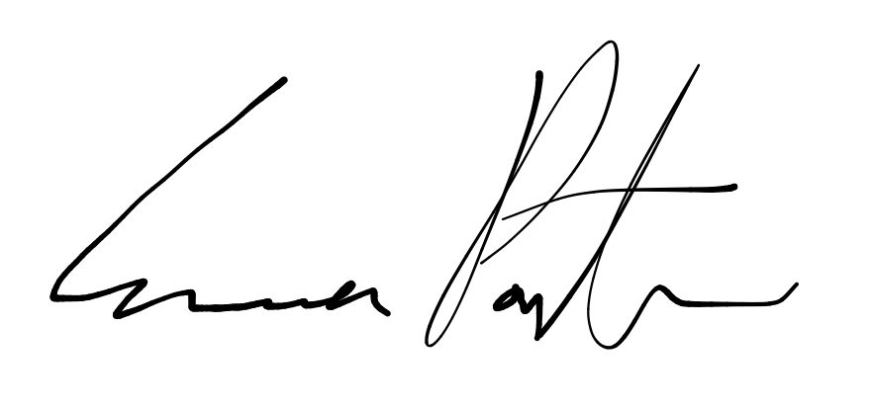

___________________________

**Emma Porter**

President

UBC Music Undergraduate Students’ Association

Respectfully submitted by

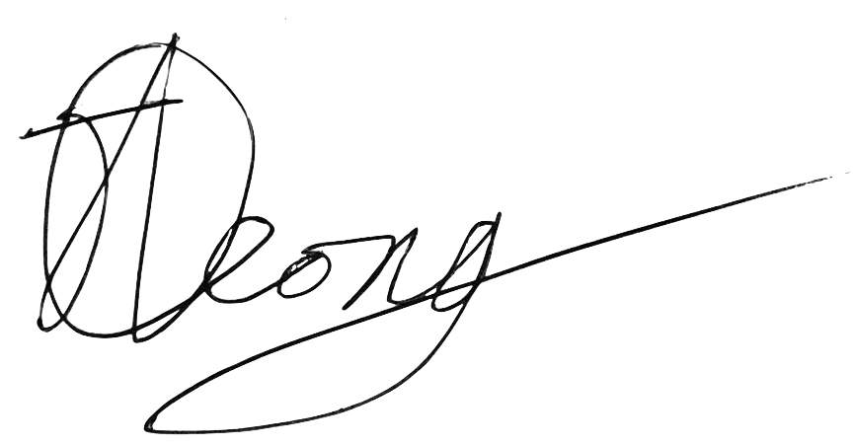

**Jobert Leong**

Vice President of Administration

UBC Music Undergraduate Students’ Association