**[ MUSA Council MINUTES ]**

Date: October 21, 2025

Time: 7:30 pm

Location: MUSA Office UBC Campus

1. **Attendance**

| **Name** | **Position** | **Attendance** |
| --- | --- | --- |
| Sayako Leznoff | President | p |
| Lucy Moon | VP Finance | p |
| Haruna Beer | VP Admin | p |
| Zaiden Grayda-Reyes | VP Internal | p |
| Deanicka Loy Sales | VP External | p |
| Mayvelee Bugh | VP Student Resource |  |
| Denise Chung | 4th Year Representative | p |
| Deckard Doerksen | 3rd Year Representative | p |
| Otis Peake | 2nd Year Representative | p |
| Eric Liu | 1st Year Representative | p |
| Caterina Cociani | 4th Floor Lounge Manager | p |

1. **Call to Order**

The meeting was called to order at 7:32 PDT

1. **Land Acknowledgement**

Saya acknowledged that UBC’s Vancouver Point Grey campus is situated on the traditional, ancestral, unceded territory of the hən̓q̓əmin̓əm̓ (Huhn-kuh-mee-nam) -speaking xʷməθkʷəy̓əm (Musqueam) people. The MUSA Council would also like to acknowledge that everyone is located in many places, near and far, and acknowledge the traditional owners and caretakers of those lands.

1. **Amendments to the Agenda**

1. **Adoption of the Agenda**

MOVED BY Deanicka , SECONDED BY Lucy .

“BE IT RESOLVED THAT the agenda be adopted as presented.”

Result: Presented

1. **Approval of Previous Meeting Minutes**

MOVED BY Lucy , SECONDED BY Zaiden .

“BE IT RESOLVED THAT the meeting minutes of 10/14/2025 be adopted as Approved .”

Result: Approved

| **VII. Agenda Items** | **VIII. Action** |
| --- | --- |
| **Introductions** | |
| * Name, Year, Position | * Done. |
| **Formal Room Booking** | |
| * Still trying to get NEST Great Hall South/North (Saturday March 21?) * Plan B: Ponderosa? | * Saya book anyways, Zaiden to post a poll to suggest Saturday rather than a usual Friday. “Will you still join us?” |
| **Caucus** | |
| * Updates? | * Emails to be distributed for people required to attend. * VP Finance: should not make the purchases, it should be someone else. |
| **4th Floor Lounge** |  |
| * Items to buy (check budget) * Halloween decorations | * Paper towels, cutlery, containers/organizers. * Longer extension cord: check office first? |
| **Bylaws and Constitution** | |
| * To update and send to Noah | * Removing the AMS Rep, reviewing what is there. |
| **Spirit Week** | |
| * Themes for each day * Post to go out by Thursday | * Vote in instagram chat to decide themes, post to go out asap |
| **Trivia Night** | |
| * Who will be there? | * Rue will run * Otis, Cat, Deckard? Participating |
| **Library Tour/Orientation** |  |
| * When? | * November 6, 12:00pm * post and posters. * Scavenger Hunt Style? No digitals: locating the scores etc, for Engagement. * Waiting on confirmation from David Haskins. |
| **AMS Council Presentation + AGM** |  |
| * Slides * Who will be at the AGM? | * Wed. Oct 22 * Saya Slide Presentation * AMS AGM 6-7 Joining Virtually etc. |
| **Rabbitats** |  |
| * When? | * Friday November 14, 2-4pm * Lucy can email to confirm |
| **MUSA Halloween Costume** |  |
| * Ideas | * Despicable Me |

**IX. Adjournment**

“BE IT RESOLVED THAT there being no further business the meeting be adjourned at

8:16pm .”

**

**Sayako Leznoff**

President

UBC Music Undergraduate Students’ Association

Respectfully submitted by

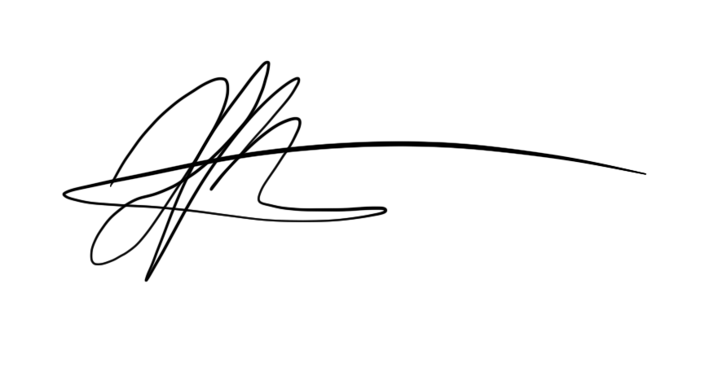

**Haruna Beer**

Vice President of Administration

UBC Music Undergraduate Students’ Association