**4[ MUSA Council AGENDA ]**

Date: 03/25/25

Time: 7:15pm PST

Location: MUSA Office

1. **Attendance**

| **Name** | **Position** | **Attendance** |
| --- | --- | --- |
| Emma Porter | President |  |
| Sayako Leznoff | VP Finance |  |
| Jobert Leong | VP Admin |  |
| Denise Chung | VP Internal |  |
| Deanicka Loy Sales | VP External |  |
| Mayvelee Bugh | VP Student Resource |  |
| Maryam Khamis | 4th Year Representative |  |
| Matthew Lew | 3rd Year Representative |  |
| Jalen Logan | 2nd Year Representative |  |
| Zaiden Grayda-Reyes | 1st Year Representative |  |

1. **Call to Order**

The meeting was called to order at _______ PDT

1. **Land Acknowledgement**

_______ acknowledged that UBC’s Vancouver Point Grey campus is situated on the traditional, ancestral, unceded territory of the hən̓q̓əmin̓əm̓-speaking xʷməθkʷəy̓əm (Musqueam) people. The MUSA Council would also like to acknowledge that everyone is located in many places, near and far, and acknowledge the traditional owners and caretakers of those lands.

1. **Amendments to the Agenda**

1. **Adoption of the Agenda**

MOVED BY _______, SECONDED BY ________.

“BE IT RESOLVED THAT the agenda be adopted as ________.”

Result:

1. **Approval of Previous Meeting Minutes**

MOVED BY ________, SECONDED BY ________.

“BE IT RESOLVED THAT the meeting minutes of _________ be adopted as _________.”

Result:

| **VII. Agenda Items** | **VIII. Action Items** |
| --- | --- |
| FBF | |
| * Friday, April 4th, 9am-12pm, SoM Lobby * Great Dane food   + Budget?   + Who will order? * Remaining photos for pick up, any unclaimed trophies, musa stickers * Schedule:   + 8:30am (coffee pick up):   + 8:30am (table set up):   + 9am-10am:   + 10am-11am:   + 11am-12pm: |  |
| Election | |
| * Last day to vote is Friday, March 28th   + Results come out the next day * We will have a meeting in April to transition the new execs into their roles |  |
| MHE - Easter Egg Painting | |
| * Thursday, March 27th, 12pm-3pm, Room 304 * Attendance?   + Who will be there to set up & tear down? * 2 tables from music office, 2 tablecloths, plastic eggs, paints and brushes, paint plates, cups for water (brush cleaning), paper towel, tea kettle, tea bags, cups, lids, stir sticks, sugar, extension cord * Order box of 50 timbits   + Emma will order them, who can pick up? * Supplies? |  |
| Music Jeopardy | |
| * Thursday, March 27th, 7:30pm, Room TBD   + Deanicka, room update? * Attendance?   + Emma will be in Seattle, can no longer attend * UBSO is hosting a movie night at the same time, conflict * Prizes? |  |
| Grad Send Off | |
| * Thursday, April 3rd, 7pm, Location TBD   + The Gallery quoted us $4000 to host there last month, and we turned them down * Location   + Do we reach out to Koerners, Browns, or take the celebration off campus? |  |
| Finals Season Care Packages | |
|  |  |

**IX. Adjournment**

“BE IT RESOLVED THAT there being no further business the meeting be adjourned at ________.”

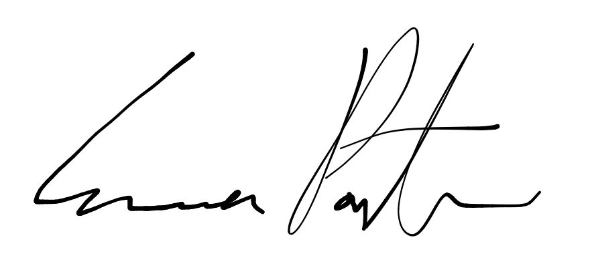

___________________________

**Emma Porter**

President

UBC Music Undergraduate Students’ Association

Respectfully submitted by

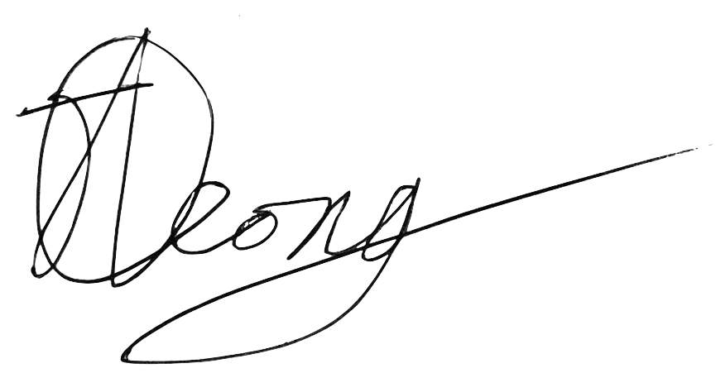

**Jobert Leong**

Vice President of Administration

UBC Music Undergraduate Students’ Association