**[ MUSA Council AGENDA ]**

Date: August 22, 2025

Time: 5 pm PST

Location: Virtual

1. **Attendance**

| **Name** | **Position** | **Attendance** |
| --- | --- | --- |
| Sayako Leznoff | President | P |
| Lucy Moon | VP Finance | P |
| Haruna Beer | VP Admin | P |
| Zaiden Grayda-Reyes | VP Internal | P |
| Deanicka Loy Sales | VP External | P |
| Mayvelee Bugh | VP Student Resource | P |
|  | 4th Year Representative |  |
|  | 3rd Year Representative |  |
|  | 2nd Year Representative |  |
|  | 1st Year Representative |  |

1. **Call to Order**

The meeting was called to order at 5:11pm PDT

1. **Land Acknowledgement**

Sayako acknowledged that UBC’s Vancouver Point Grey campus is situated on the traditional, ancestral, unceded territory of the hən̓q̓əmin̓əm̓-speaking xʷməθkʷəy̓əm (Musqueam) people. The MUSA Council would also like to acknowledge that everyone is located in many places, near and far, and acknowledge the traditional owners and caretakers of those lands.

1. **Amendments to the Agenda**

1. **Adoption of the Agenda**

MOVED BY Deanicka , SECONDED BY Lucy .

“BE IT RESOLVED THAT the agenda be adopted as __Approved______.”

Result:

1. **Approval of Previous Meeting Minutes**

MOVED BY Zaiden , SECONDED BY Lucy .

“BE IT RESOLVED THAT the meeting minutes of May 5th, 2025 be adopted as ___Approved______.”

Result:

| **VII. Agenda Items** | **VIII. Action Items** |
| --- | --- |
| Jumpstart Resource Fair | |
| * MUSA booth reserved! Set up 2:30-4:00, Booth 4:00-7:00, AUGUST 27. Who’s boothing? * Buy timbits * Prepare stickers/other SoM merch | * Boothing   + Saya & Mayvelee * |
| Imagine Day | |
| * Set up 10:30 and Boothing 11:30-1:30 on SEPTEMBER 2 * Who can booth? * Buy timbits + bring stickers/other merch | * Boothing   + Rue all day , Saya 10:30-12:30, & Mayvelee after 12-1:30 * Timbits * MUSA stickers   + Hand cut them - Lucy, Deanicka, Saya   + Print them at Staples before the 27th   + Lucy will leave stickers at the office on the 26th   + Saya will look for sticker places   + Lucy might be able to provide stickers   -Mayvelee to get ubc merch pencils etc from Kathryn in the office. |
| Lockers | |
| * Boothing SEPTEMBER 3-12, 9-12 * Consult locker protocol in MUSA Drive * when2meet for locker boothing | * Boothing   + When to meet will be sent out   + One person at all times *Don’t leave cashbox alone* * Rue will look through old lockers from past students * Saya sends an email with important dates to all students   + Mayvelee will send mass email lists * Make more room for cello students   + More prioritized for lockers |
| Free Breakfast Friday | |
| * The first one is SEPTEMBER 5 * Boothing 9-12 (who will booth? who will pick up food? food from where?) | * Saya will talk to Great Dane for first FBF, Tim Hortons back up plan * Budget below 150$ * Deanicka & Saya pick up food 8:30 and set up with Lucy * 9:00 - 10:00: Lucy, Zaiden * 10:00 - 11:00: Lucy, Rue * 11:00 - 12:00: Rue, Deanicka |
| Koerner’s Night | |
| * Sometime in the week of 22-26? * Somebody to book Koerner’s :) | * Deanicka will book for the 25th of September for 7:00pm - 11:00pm * Zaiden make post clear that it isn’t for minors |
| Rehearsal Etiquette Workshop | |
| * Still planning dates with Dr. Girard and Dr. Hermiston, but will be in the week of SEPTEMBER 8-12 | * Both said yes, they just need to figure out schedule * Lucy if available is free to be the mediator   + Only on campus Tuesday (12-1/ Orchestra time) and Thursday (difficult to schedule * Room number TBD |
| Spirit Week | |
| * SEPTEMBER 15-19 | * DATE CHANGE: October 27th-31st, leading up to Halloween and after students are a bit more established. |
| Student Life Caucus | |
|  | * First year get together - Later in September 15-29 * All year event “Welcome/Welcome back”   + Chalk, snacks, pens, signing (make a video)   + Faculty colour |

**IX. Adjournment**

“BE IT RESOLVED THAT there being no further business the meeting be adjourned at 6:08pm .”

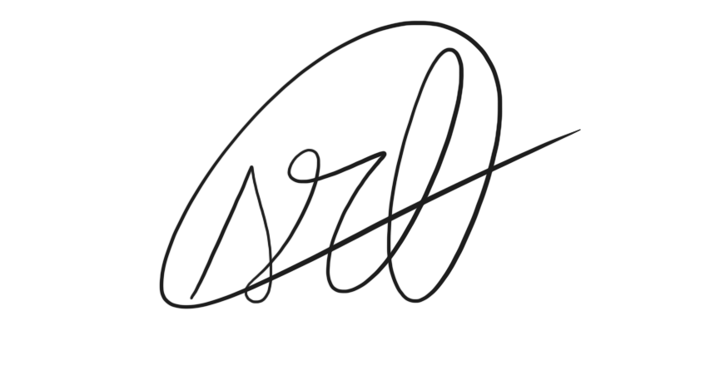

___________________________

**Sayako Leznoff**

President

UBC Music Undergraduate Students’ Association

Respectfully submitted by

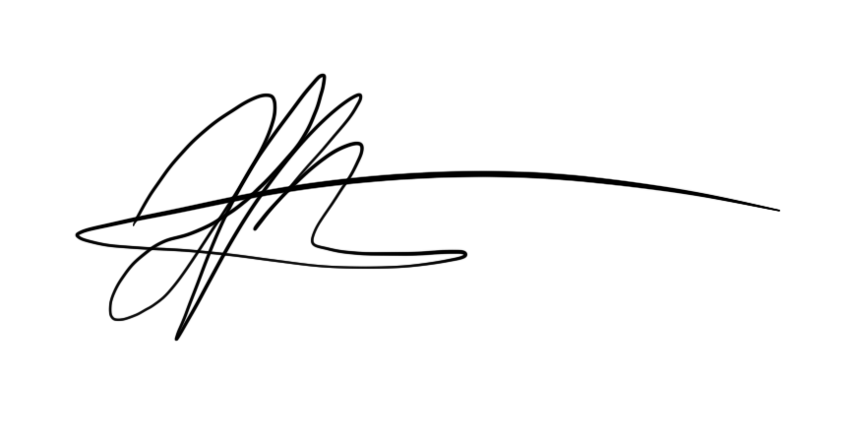

**Haruna Beer**

Vice President of Administration

UBC Music Undergraduate Students’ Association