[ MUSA Council AGENDA ]

Date: 10/30/23
Time: 8 am
Location: MUSA Office

- Attendance

Name | Position | Attendance
Amelia Walker | President | P
Sayako Leznoff | VP Finance | L
Emma Porter | VP Admin | P
Indira Graham | VP Internal | P
Rue Beer | VP External | L
Phoebe Cheng | AMS Representative | P
Mika Colonia | 4th Year Representative | L
Maryam Khamis | 3rd Year Representative | P
 | 2nd Year Representative
JJ Logan | 1st Year Representative | P
Jeremy Soloman | 4th Floor Lounge Manager | P

- Call to Order

The meeting was called to order at 8:03am PDT

- Land Acknowledgement

Amelia acknowledged that UBC’s Vancouver Point Grey campus is situated on the traditional, ancestral, unceded territory of the hən̓q̓əmin̓əm̓-speaking xʷməθkʷəy̓əm (Musqueam) people. The MUSA Executive Committee would also like to acknowledge that everyone is located in many places, near and far, and acknowledge the traditional owners and caretakers of those lands.

- Amendments to the Agenda

- Adoption of the Agenda

MOVED BY Amelia Walker , SECONDED BY Jeremy Solomon .
“BE IT RESOLVED THAT the agenda be adopted as amended.”
Result: APPROVED
- Approval of Previous Meeting Minutes

MOVED BY Emma Porter, SECONDED BY Indira Graham.
“BE IT RESOLVED THAT the meeting minutes of 10/23/23 be adopted as distributed.”

Result: APPROVED

- Agenda Items
- Contact Sheet
  - JJ and Jeremy please fill out the contact sheet
    - Already done
- Update the board
  - Add everyone's photo, name, pronouns
    - JJ please submit your headshot, bio, pronouns to the Website Headshot document
      - Already done
- Charity Concert Social Media
  - Should do another post, this week to promote, as we cannot get an interview till next week
    - Maybe? We do something like come with me to go to the AMS Food Bank?
      - Ideas
      - Post the poster this week, the interview next week
  - Year reps: Please encourage year to participate
- Revamp the Website
  - Fit our Instagram theme!
    - Rue work with Indira to make the website cohesive with the theme of the instagram
      - Time set?
        - October 30th, 3pm
  - Add people bio, name, pronouns, Most are there now
- Koerner's Night
  - Good and Bads?
    - Good turnout after the CW concert
    - Conflicted with the CW concert
      - Karaoke ended pretty soon after cw people showed up
    - Rough guess of 60 people
- MUSA Group Costume
  - We are going to be farm animals this year
    - Amelia: cow, Jeremy: sheep, Saya: duck, Phoebe: pig, JJ: dog, Mika: rabbit, Maryam: bunny, Rue: cat, Emma: deer
    - 9am meet in the music lobby
- Decorating lounge for Halloween
  - When?
    - Already decorated
- Mini Fridge Rules
  - Jeremy, wanna explain?
    - Sign was put up
      - Refrain from putting food in the fridge overnight
      - Every monday, Jermeny will empty the fridge and clean out any leftover food
- Halloween Manhunt in Music Building
  - Today
  - Badges
  - There: Jeremy, Emma, Indira, Phoebe, Rue, JJ, Maryam
    - Emma and I will walk around ensure people are following rules
    - Indira and Maryam: Will watch the jail, located in basement
      - In the corner near the entrance to the parkade
    - No Caution Tape, But we have regular tape, Gonna have to work
    - The rest play the game?
  - Prep:
    - Who can before the event:
      - Put up the tape on 338, 339, and early music
        - Emma
      - Hide the Violin-> Amelia will after 7:30
      - Set up jail, tape up a hexa on the floor
        - Indira and Maryam
      - Anymore Prep?
- Meeting with Carabre
  - Gender Neutral Bathroom is located on First Floor, Going to promote it better
- November Plan:
  - Free Breakfast Friday -> November 3rd
    - Saya pick up the pastries 8:30am
    - Emma and JJ pick up coffee 8:30am
  - Amelia pick up the table from office and set up 8:45am
  - Everyone should sign up for a boothing time
    - Will send that out today
  - Alexander Technique Workshop
    - November 10, 2023
    - 1pm, room?
      - Emma book the room (113 or Barnett hopefully)
        - Booked 113, will confirm and send out
    - Post go out last week of October, NEXT WEEK ON 31st
    - Original person had to cancel the workshop. Will talk to Kathryn in the office about potentially hosting the workshop instead
      - Amelia will reach out to Kathryn today
  - Movie Night
    - AMS Building
      - Nothing on that yet
        - Will follow up to Ian
          - Talked to Ian, Wednesday, He said he’s going to see if we can use the Hatch Gallery
            - Not confirmed tho
  - Date?
    - Friday, November 17th
      - 8pm
  - Studio Ghibli theme again?
    - When should we send out Movie survey
  - Attached to Social Media Post
      - WHEN?
        - Post to go out next week
          - Even if we don’t have a room, post it
  - MUSA team make some decorations
    - Amelia to make decorations
      - Thursday, November 16th, 12pm-4pm
  - Refreshments for the event
    - Pizza
      - Rue order the pizza on November 13th
    - Pop
      - Bring your own drinks
      - MUSA make hot chocolate
        - Amelia purchasing before the event
- MUSA Retreat
  - Budget?
    - $250
  - What do we wanna do and when
    - Sometime in the end of November
    - Emma will send a when2meet for some weekends
    - VSO, potluck at someone’s house, other options
- December events
  - Christmas/ Hanukkah
    - Do we have any Hanukkah decorations
      - Could we purchase some?
      - MUSA to invest in decorations, consult Saya
  - Free Breakfast Friday
    - December 1st
  - Anything else
    - Christmas Event
      - December 4th
        - Lounge party, holiday karaoke
- What else?
- Housekeeping
  - If you missing things from people and can’t complete your part of task, remind them
    - We are a part of team and people do forget things it is natural, but don’t delay your half of a project because someone forgot something
    - MUSA Audience Policy
      - Three unexcused absences, then you are kicked out
- Action Items
- Rue and Indira: meet at 3pm today to discuss the website revamp and work on it together
- Emma: put tape on the doors of rooms for the manhunt
- Amelia: hide the little violin before the manhunt
- Emma and JJ: pick up the coffee at 8:30am
- Saya: pick up the pastries at 8:30am
- Amelia: set up the table at 8:45am
- Everybody: fill out the when2meet for FBF and retreat
- Saya: look into Hanukkah decorations

- Adjournment

“BE IT RESOLVED THAT there being no further business the meeting be adjourned at 8:43am .”

___________________________
Amelia Walker
President
UBC Music Undergraduate Students’ Association

Respectfully submitted by

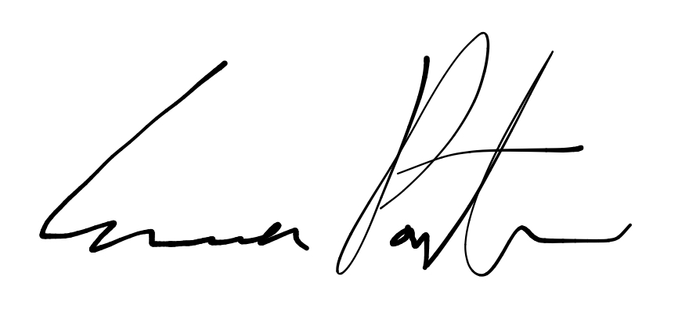

Emma Porter
Vice President of Administration
UBC Music Undergraduate Students’ Association

