**[ MUSA Council AGENDA ]**

Date:

Time:

Location:

1. **Attendance**

| **Name** | **Position** | **Attendance** |
| --- | --- | --- |
| Sayako Leznoff | President |  |
| Lucy Moon | VP Finance |  |
| Haruna Beer | VP Admin |  |
| Zairean Grayda-Reyes | VP Internal |  |
| Deanicka Loy Sales | VP External |  |
| Mayvelee Bugh | VP Student Resource |  |
|  | 4th Year Representative |  |
|  | 3rd Year Representative |  |
|  | 2nd Year Representative |  |
|  | 1st Year Representative |  |

1. **Call to Order**

The meeting was called to order at PDT

1. **Land Acknowledgement**

acknowledged that UBC’s Vancouver Point Grey campus is situated on the traditional, ancestral, unceded territory of the hən̓q̓əmin̓əm̓-speaking xʷməθkʷəy̓əm (Musqueam) people. The MUSA Council would also like to acknowledge that everyone is located in many places, near and far, and acknowledge the traditional owners and caretakers of those lands.

1. **Amendments to the Agenda**

1. **Adoption of the Agenda**

MOVED BY , SECONDED BY .

“BE IT RESOLVED THAT the agenda be adopted as ________.”

Result:

1. **Approval of Previous Meeting Minutes**

MOVED BY , SECONDED BY .

“BE IT RESOLVED THAT the meeting minutes of be adopted as _________.”

Result:

| **VII. Agenda Items** | **VIII. Action Items** |
| --- | --- |
| Jumpstart Resource Fair | |
| * MUSA booth reserved! Set up 2:30-4:00, Booth 4:00-7:00, AUGUST 27. Who’s boothing? * Buy timbits * Prepare stickers/other SoM merch |  |
| Imagine Day | |
| * Set up 10:30 and Boothing 11:30-1:30 on SEPTEMBER 2 * Who can booth? * Buy timbits + bring stickers/other merch |  |
| Lockers | |
| * Boothing SEPTEMBER 3-12, 9-12 * Consult locker protocol in MUSA Drive * when2meet for locker boothing |  |
| Free Breakfast Friday | |
| * The first one is SEPTEMBER 5 * Boothing 9-12 (who will booth? who will pick up food? food from where?) |  |
| Koerner’s Night | |
| * Sometime in the week of 22-26? * Somebody to book Koerner’s :) |  |
| Rehearsal Etiquette Workshop | |
| * Still planning dates with Dr. Girard and Dr. Hermiston, but will be in the week of SEPTEMBER 8-12 |  |
| Spirit Week | |
| * SEPTEMBER 15-19 |  |

**IX. Adjournment**

“BE IT RESOLVED THAT there being no further business the meeting be adjourned at .”

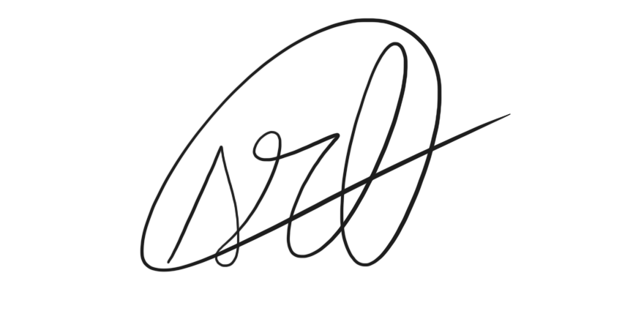

___________________________

**Sayako Leznoff**

President

UBC Music Undergraduate Students’ Association

Respectfully submitted by

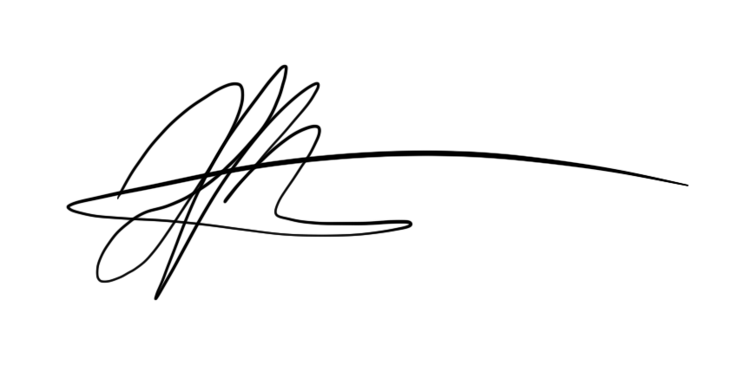

**Haruna Beer**

Vice President of Administration

UBC Music Undergraduate Students’ Association