**[ MUSA Council AGENDA ]**

Date:

Time:

Location:

1. **Attendance**

| **Name** | **Position** | **Attendance** |
| --- | --- | --- |
| Sayako Leznoff | President |  |
| Lucy Moon | VP Finance |  |
| Haruna Beer | VP Admin |  |
| Zaiden Grayda-Reyes | VP Internal |  |
| Deanicka Loy Sales | VP External |  |
| Mayvelee Bugh | VP Student Resource |  |
|  | 4th Year Representative |  |
|  | 3rd Year Representative |  |
|  | 2nd Year Representative |  |
|  | 1st Year Representative |  |

1. **Call to Order**

The meeting was called to order at PDT

1. **Land Acknowledgement**

acknowledged that UBC’s Vancouver Point Grey campus is situated on the traditional, ancestral, unceded territory of the hən̓q̓əmin̓əm̓ (Huhn-kuh-mee-nam) -speaking xʷməθkʷəy̓əm (Musqueam) people. The MUSA Council would also like to acknowledge that everyone is located in many places, near and far, and acknowledge the traditional owners and caretakers of those lands.

1. **Amendments to the Agenda**

1. **Adoption of the Agenda**

MOVED BY , SECONDED BY .

“BE IT RESOLVED THAT the agenda be adopted as ________.”

Result:

1. **Approval of Previous Meeting Minutes**

MOVED BY , SECONDED BY .

“BE IT RESOLVED THAT the meeting minutes of be adopted as _________.”

Result:

| **VII. Agenda Items** | **VIII. Action** |
| --- | --- |
| **Trivia Night** | |
| * Tomorrow!! * Anything else needed or to be done? |  |
| **First Year Social** | |
| * Update on shopping list * Who can set up/takedown * If raining, do we have a room * Instagram post |  |
| **AMS Council** | |
| * Chan Centre presentation pushed back to meeting of Oct. 22 |  |
| **Dr. Law Email/Meeting** | |
| * No reply since requesting for statement and inviting her to meeting today |  |
| **Chan Centre** | |
| * UBCSO concert speech * David Lemon email * Next steps |  |
| **East Vancouver Community Music School** | |
|  |  |
|  |  |
|  |  |

**IX. Adjournment**

“BE IT RESOLVED THAT there being no further business the meeting be adjourned at .”

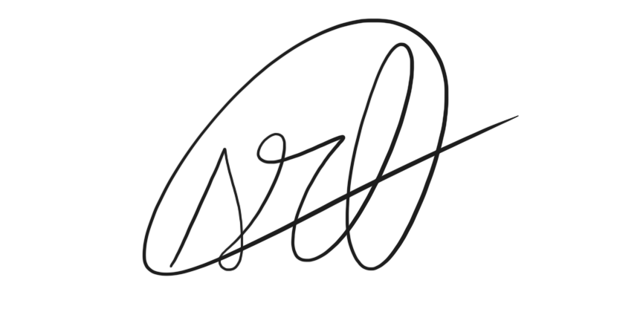

___________________________

**Sayako Leznoff**

President

UBC Music Undergraduate Students’ Association

Respectfully submitted by

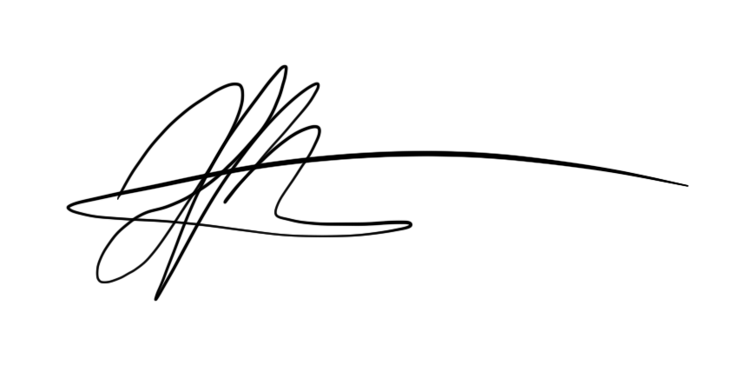

**Haruna Beer**

Vice President of Administration

UBC Music Undergraduate Students’ Association