**[ MUSA Council AGENDA ]**

Date: 02/26/25

Time: 8:00am PST

Location: MUSA Office + Discord

1. **Attendance**

| **Name** | **Position** | **Attendance** |
| --- | --- | --- |
| Emma Porter | President | P |
| Sayako Leznoff | VP Finance | P |
| Jobert Leong | VP Admin | P |
| Denise Chung | VP Internal | L |
| Deanicka Loy Sales | VP External | E |
| Mayvelee Bugh | VP Student Resource | L |
| Maryam Khamis | 4th Year Representative | E |
| Matthew Lew | 3rd Year Representative | E |
| Jalen Logan | 2nd Year Representative | L |
| Zaiden Grayda-Reyes | 1st Year Representative |  |

1. **Call to Order**

The meeting was called to order at ______ PDT

1. **Land Acknowledgement**

acknowledged that UBC’s Vancouver Point Grey campus is situated on the traditional, ancestral, unceded territory of the hən̓q̓əmin̓əm̓-speaking xʷməθkʷəy̓əm (Musqueam) people. The MUSA Council would also like to acknowledge that everyone is located in many places, near and far, and acknowledge the traditional owners and caretakers of those lands.

1. **Amendments to the Agenda**

1. **Adoption of the Agenda**

MOVED BY , SECONDED BY .

“BE IT RESOLVED THAT the agenda be adopted as .”

Result:

1. **Approval of Previous Meeting Minutes**

MOVED BY , SECONDED BY .

“BE IT RESOLVED THAT the meeting minutes of be adopted as _________.”

Result:

| **VII. Agenda Items** | **VIII. Action Items** |
| --- | --- |
| MHE - Flower Crowns | |
| * Thursday, Feb 27th, 12pm-3pm * Attendance? * Have supplies been picked up yet? |  |
| Candy Grams | |
| * Any that haven’t been picked up, have arrangements been made to collect them? |  |
| Social Media Posts | |
| * Insta Reels   + Dance videos ready to post by end of this week   + Any other reels? * Please share all our posts to social media and encourage your friends and other students to attend |  |
| Elections | |
| * AGM will be Thursday, March 20th, 2pm, Room 338   + Will buy pizza   + Students will give their election speeches either in person or through a video submission * Email will be sent out by Jeremy to students on Feb 24th * Post will also go up on Feb 24th * AMS Elections   + Endorsements |  |
| Formal | |
| * Posters have been put up around SoM, thank you to Denise! * Please share the insta post on your story and with your friends * Early bird ticket sales go live Feb 24th on Bounce   + Saya has created the event * Decorations   + There is a new channel on discord specifically for decorations     - Please out in your suggestions, as we need a finalized shopping list by the end of the week   + Date to make all the decorations     - https://www.when2meet.com/?29232625-IHmBY * Catering   + Order will be placed as discussed last meeting   + For drinks, there will be red+white wine, mimosas, beer, and non-alcoholic options * Photobooth   + What backdrop do we want? * Floor Plan * Superlatives   + Decide on categories today, send out to students and put up posters friday |  |
| Movie Night | |
| * Friday, February 28th, 6:30pm, Room 462 * Attendance?   + Set up and tear down volunteers * Castle in the Sky themed decorations * Pizza again   + Order bigger pizzas to make sure we feed everyone * Pull in couches from lounge |  |

**IX. Adjournment**

“BE IT RESOLVED THAT there being no further business the meeting be adjourned at .”

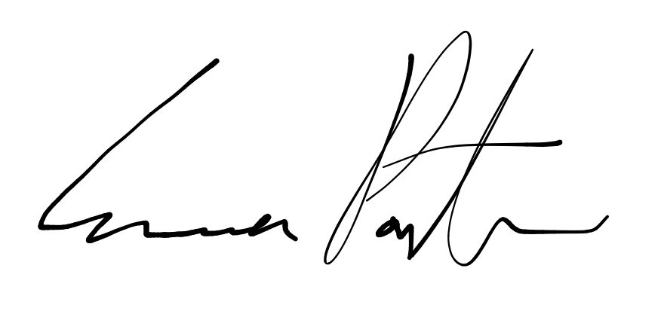

___________________________

**Emma Porter**

President

UBC Music Undergraduate Students’ Association

Respectfully submitted by

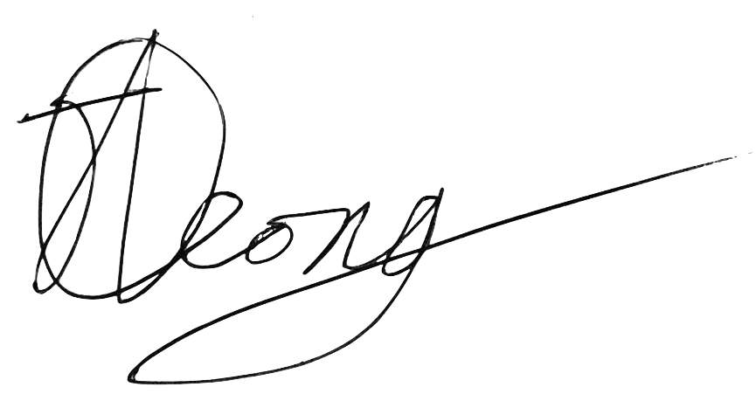

**Jobert Leong**

Vice President of Administration

UBC Music Undergraduate Students’ Association