**[ MUSA Council AGENDA ]**

Date: 10/23/24

Time: 8:00am

Location: MUSA Office

1. **Attendance**

| **Name** | **Position** | **Attendance** |
| --- | --- | --- |
| Emma Porter | President |  |
| Sayako Leznoff | VP Finance |  |
| Jobert Leong | VP Admin |  |
| Denise Chung | VP Internal |  |
| Deanicka Loy Sales | VP External |  |
| Mayvelee Bugh | VP Student Resource |  |
| Maryam Khamis | 4th Year Representative |  |
| Matthew Lew | 3rd Year Representative |  |
| Jalen Logan | 2nd Year Representative |  |
| Zaiden Grayda-Reyes | 1st Year Representative |  |

1. **Call to Order**

The meeting was called to order at PDT

1. **Land Acknowledgement**

acknowledged that UBC’s Vancouver Point Grey campus is situated on the traditional, ancestral, unceded territory of the hən̓q̓əmin̓əm̓-speaking xʷməθkʷəy̓əm (Musqueam) people. The MUSA Council would also like to acknowledge that everyone is located in many places, near and far, and acknowledge the traditional owners and caretakers of those lands.

1. **Amendments to the Agenda**

1. **Adoption of the Agenda**

MOVED BY , SECONDED BY .

“BE IT RESOLVED THAT the agenda be adopted as ________.”

Result:

1. **Approval of Previous Meeting Minutes**

MOVED BY , SECONDED BY .

“BE IT RESOLVED THAT the meeting minutes of be adopted as _________.”

Result:

| **VII. Agenda Items** | **VIII. Action Items** |
| --- | --- |
| New Team Introductions | |
| * Welcome to Deanicka, Mayvelee, Maryam, and Zaiden * Intros   + Year, instrument, major, what you’re most excited about for the year |  |
| Movie Night Recap | |
| * General thoughts?   + What went well, what would you change * Do we have any/enough photos to post a recap on instagram? |  |
| Pumpkin Carving | |
| * October 29th, 7pm * Who will be there? * Post to go up today |  |
| Halloween | |
| * Costumes have been finalized * Is there a time where all of us are free to take a photo together in costume? |  |
| Faculty Trick-or-treating | |
| * Email has been sent out to all faculty listed on the ubc website   + Yes so far from:     - Dr. Jun     - Paolo     - Mark Anderson     - Prof. Chan (maybe)     - Nancy Hermiston * Post about the event to go up tomorrow   + Let students know to look out for decorated doors * What will we use to decorate the doors of participating faculty? |  |
| Free Breakfast Friday | |
| * November 1st, 9am-12pm, SoM lobby * when2meet has been sent in slack, please fill out now * Who will pick up the food? * Who will set up the table in the lobby? | |
| Rabbitats | |
| * November 1st, 3pm-5pm, SoM lobby   + All big rooms are taken so we will set up in the lobby. They will bring pens for the bunnies * Post to go up Friday   + Check out @ubcrabbitats for inspo * Who will be there? | |
| Colouring Event | |
| * November 21st, 12pm-3pm, MUSA Office * Post to go up November 7th * Who will be there? * In the MUSA drive, there is a folder that you can  add blank colouring pages to   + Emma will print them before the event * Do we need to buy coloured pencils? | |
| Gallery Night | |
| * November 20th, or 22nd * Once we have a date decided, more details can be  decided | |

**IX. Adjournment**

“BE IT RESOLVED THAT there being no further business the meeting be adjourned at .”

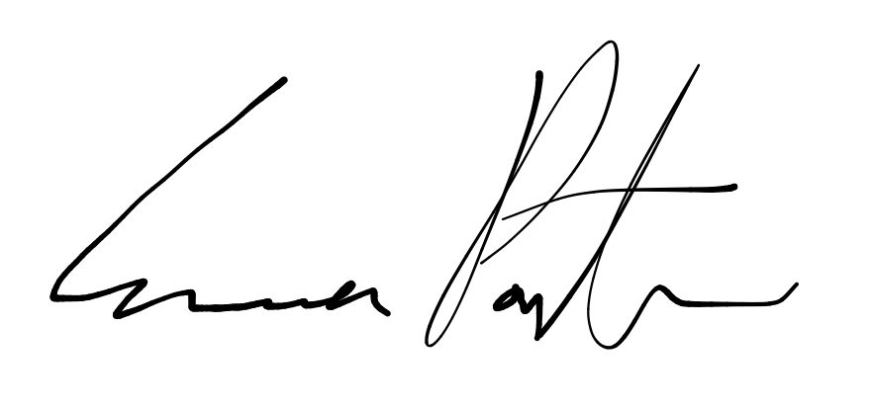

___________________________

**Emma Porter**

President

UBC Music Undergraduate Students’ Association

Respectfully submitted by

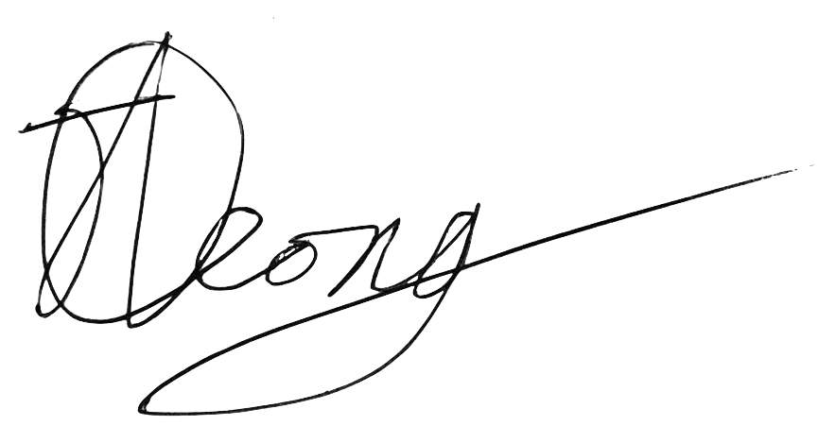

**Jobert Leong**

Vice President of Administration

UBC Music Undergraduate Students’ Association