**[ MUSA Council AGENDA ]**

Date: 01/14/25

Time: 7:30pm

Location: MUSA Office

1. **Attendance**

| **Name** | **Position** | **Attendance** |
| --- | --- | --- |
| Emma Porter | President | P |
| Sayako Leznoff | VP Finance | P |
| Jobert Leong | VP Admin | P |
| Denise Chung | VP Internal | P |
| Deanicka Loy Sales | VP External | P |
| Mayvelee Bugh | VP Student Resource | P |
| Maryam Khamis | 4th Year Representative | P |
| Matthew Lew | 3rd Year Representative | P |
| Jalen Logan | 2nd Year Representative | P |
| Zaiden Grayda-Reyes | 1st Year Representative | P |

1. **Call to Order**

The meeting was called to order at ______ PDT

1. **Land Acknowledgement**

acknowledged that UBC’s Vancouver Point Grey campus is situated on the traditional, ancestral, unceded territory of the hən̓q̓əmin̓əm̓-speaking xʷməθkʷəy̓əm (Musqueam) people. The MUSA Council would also like to acknowledge that everyone is located in many places, near and far, and acknowledge the traditional owners and caretakers of those lands.

1. **Amendments to the Agenda**

1. **Adoption of the Agenda**

MOVED BY , SECONDED BY .

“BE IT RESOLVED THAT the agenda be adopted as .”

Result:

1. **Approval of Previous Meeting Minutes**

MOVED BY , SECONDED BY .

“BE IT RESOLVED THAT the meeting minutes of be adopted as _________.”

Result:

| **VII. Agenda Items** | **VIII. Action Items** |
| --- | --- |
| Interfaculty Cup | |
| - |  |
| Scheduling | |
|  |  |
| MUSA Council Photo | |
| * When2meet has been sent in slack for possible dates and times to take our group photo. Preferably before the end of march * If you are an exec, you also get a headshot for the composite and business headshots   + You can book your appointment with Evangelos whenever! |  |
| Retreat | |
| * Once again, there is no time where all 10 of us are free |  |
| Social Media | |
| * Posts to go out soon:   + MHE   + Candy grams |  |
| Candy Grams | |
| * Origami hearts, candy bags   + $2 heart, $3 candy bag * Boothing the 2 weeks leading up to Valentine’s Day (Feb 3-7, 10-13) 9am-2pm   + Schedule sent in the slack, please put it into your calendar! |  |
| Formal | |
| * Venue   + Great Hall is under construction from February 10th-March 16th   + We need to pick and book another venue today so that the post can go out this week     - Different options have been sent into the chat * Decorations   + Shared google doc has been put in the drive, we can add ideas in there * Photo Booth   + I will contact 5M once we have secured a venue * Tickets   + $15 early bird, $20 regular, $25 at the door     - Bounce App       * Saya will set up the event on Bounce and Denise will help with the poster/graphics * Music   + Parker has agreed to DJ again |  |
| Mental Health Event | |
| * Lunar New Year * Post to go up tomorrow * Supplies update |  |
| Director Search | |
| * Update? |  |

**IX. Adjournment**

“BE IT RESOLVED THAT there being no further business the meeting be adjourned at .”

**

___________________________

**Emma Porter**

President

UBC Music Undergraduate Students’ Association

Respectfully submitted by

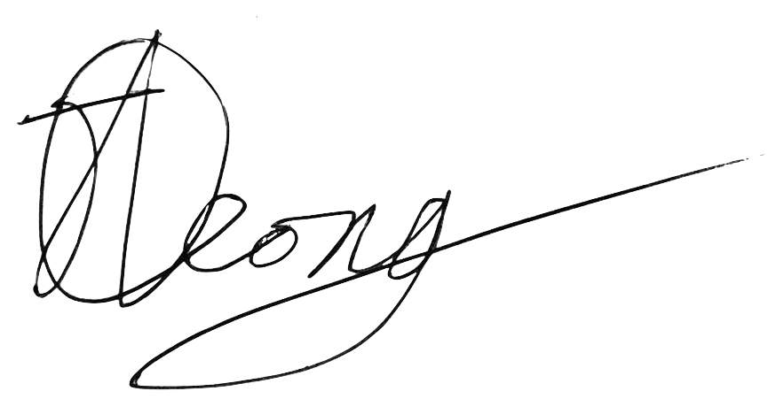

**Jobert Leong**

Vice President of Administration

UBC Music Undergraduate Students’ Association