**[ MUSA Council AGENDA ]**

Date: 10/09/24

Time: 8:00AM

Location: MUSA Office

1. **Attendance**

| **Name** | **Position** | **Attendance** |
| --- | --- | --- |
| Emma Porter | President |  |
| Sayako Leznoff | Interim VP Finance |  |
| Jobert Leong | VP Admin |  |
| Denise Chung | VP Internal |  |
|  | VP External |  |
|  | VP Student Resource |  |
|  | 4th Year Representative |  |
| Matthew Lew | 3rd Year Representative |  |
| JJ Logan | 2nd Year Representative |  |
|  | 1st Year Representative |  |

1. **Call to Order**

The meeting was called to order at PDT

1. **Land Acknowledgement**

acknowledged that UBC’s Vancouver Point Grey campus is situated on the traditional, ancestral, unceded territory of the hən̓q̓əmin̓əm̓-speaking xʷməθkʷəy̓əm (Musqueam) people. The MUSA Council would also like to acknowledge that everyone is located in many places, near and far, and acknowledge the traditional owners and caretakers of those lands.

1. **Amendments to the Agenda**

1. **Adoption of the Agenda**

MOVED BY , SECONDED BY .

“BE IT RESOLVED THAT the agenda be adopted as ________.”

Result:

1. **Approval of Previous Meeting Minutes**

MOVED BY , SECONDED BY .

“BE IT RESOLVED THAT the meeting minutes of be adopted as _________.”

Result:

| **VII. Agenda Items** | **VIII. Action Items** |
| --- | --- |
| Elections | |
| * Delay in election   + Jeremy didn’t submit election papers in a timely matter and AMS has requested minimum 2 weeks.   + Jeremy will send the email will the voting when it is ready * 2nd and 3rd Year Rep   + Welcome to Matty and JJ!! |  |
| Retreat | |
| * Thank you all for voting in the poll   + Dinner and drinks seem to be winning so far. We will wait for the rest of the team to be elected before making our final decision |  |
| Inside Out 2 Movie Night | |
| * Instagram post to go out today   + Poster to be sent to Jeremy to go up in the lounge   + Location can say: AMS Nest, Room TBA |  |
| EcoVillage Dog Therapy | |
| * Dog therapy costs $1700??   + We will do something else at a more cost efficient price |  |
| Halloween Event | |
| * Any ideas for events? * Waiting on responses from profs regarding trick-or-treating at offices   + If this is a go, should musa offer to decorate doors for profs? |  |
|  |  |
|  |  |

1. **Adjournment**

“BE IT RESOLVED THAT there being no further business the meeting be adjourned at .”

**

___________________________

**Emma Porter**

President

UBC Music Undergraduate Students’ Association

Respectfully submitted by

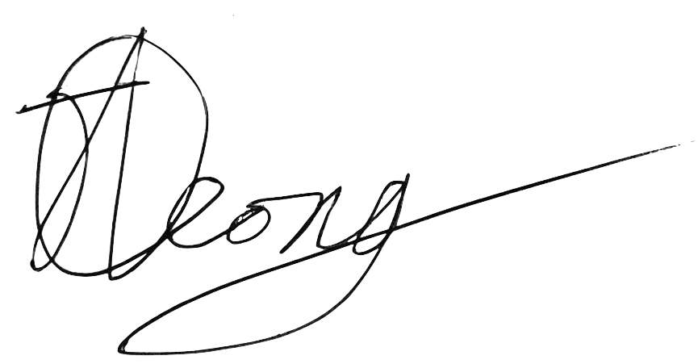

**Jobert Leong**

Vice President of Administration

UBC Music Undergraduate Students’ Association