**[ MUSA Council MINUTES ]**

Date: October 7, 2025

Time: 7:30pm

Location: UBC MUSA Office

1. **Attendance**

| **Name** | **Position** | **Attendance** |
| --- | --- | --- |
| Sayako Leznoff | President | p |
| Lucy Moon | VP Finance | p |
| Haruna Beer | VP Admin | p |
| Zaiden Grayda-Reyes | VP Internal | p |
| Deanicka Loy Sales | VP External | a |
| Mayvelee Bugh | VP Student Resource | p |
|  | 4th Year Representative |  |
|  | 3rd Year Representative |  |
|  | 2nd Year Representative |  |
|  | 1st Year Representative |  |

1. **Call to Order**

The meeting was called to order at 7:40 PDT

1. **Land Acknowledgement**

Sayako acknowledged that UBC’s Vancouver Point Grey campus is situated on the traditional, ancestral, unceded territory of the hən̓q̓əmin̓əm̓ (Huhn-kuh-mee-nam) -speaking xʷməθkʷəy̓əm (Musqueam) people. The MUSA Council would also like to acknowledge that everyone is located in many places, near and far, and acknowledge the traditional owners and caretakers of those lands.

1. **Amendments to the Agenda**

none

1. **Adoption of the Agenda**

MOVED BY Mayvelee , SECONDED BY Zaiden .

“BE IT RESOLVED THAT the agenda be adopted as Presented.”

Result: Presented

1. **Approval of Previous Meeting Minutes**

MOVED BY Lucy , SECONDED BY Saya .

“BE IT RESOLVED THAT the meeting minutes of 9/30/2025 be adopted as Approved.”

Result: Approved

| **VII. Agenda Items** | **VIII. Action** |
| --- | --- |
| **Trivia Night** | |
| * Tomorrow!! * Anything else needed or to be done? | * No Actions! |
| **First Year Social** | |
| * Update on shopping list * Who can set up/takedown * If raining, do we have a room * Instagram post | * Chalk Zaiden will bring * Speaker Rue * 11:30 (Set-up): Saya and Rue * 12:00 * 1:00 * 2:00 (Take-down):Rue * Backup Room (in case of weather): Room 304 |
| **AMS Council** | |
| * Chan Centre presentation pushed back to meeting of Oct. 22 |  |
| **Dr. Law Email/Meeting** | |
| * No reply since requesting for statement and inviting her to meeting today | * Waiting for a reply. |
| **Chan Centre** | |
| * UBCSO concert speech * David Lemon email * Next steps | * Meeting with Hedy * Meeting with the Dean of Arts, when the date is determined we can see who is available. * The next step following is to determine protest: next steps? |
| **East Vancouver Community Music School** | |
|  | * Rue will reply no thank you |
|  |  |
|  |  |

**IX. Adjournment**

“BE IT RESOLVED THAT there being no further business the meeting be adjourned at 8:29 .”

**

**Sayako Leznoff**

President

UBC Music Undergraduate Students’ Association

Respectfully submitted by

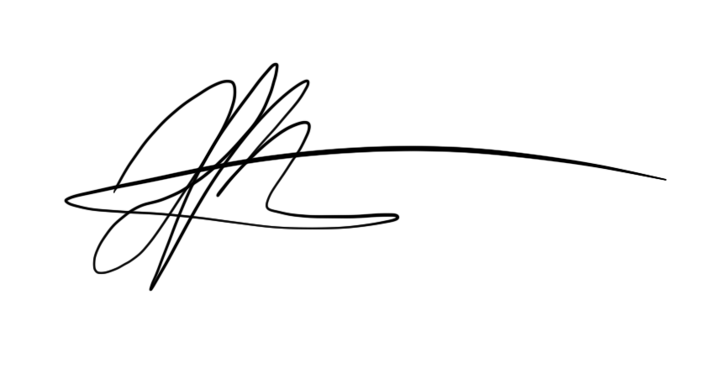

**Haruna Beer**

Vice President of Administration

UBC Music Undergraduate Students’ Association