**[ MUSA Council AGENDA ]**

Date: 09/18/24

Time: 8:00am

Location: MUSA Office

1. **Attendance**

| **Name** | **Position** | **Attendance** |
| --- | --- | --- |
| Emma Porter | President |  |
| Sayako Leznoff | Interim VP Finance |  |
| Jobert Leong | VP Admin |  |
| Denise Chung | VP Internal |  |
|  | VP External |  |
|  | AMS Representative |  |
|  | 4th Year Representative |  |
|  | 3rd Year Representative |  |
|  | 2nd Year Representative |  |
|  | 1st Year Representative |  |
|  | 4th Floor Lounge Manager |  |

1. **Call to Order**

The meeting was called to order at PDT

1. **Land Acknowledgement**

acknowledged that UBC’s Vancouver Point Grey campus is situated on the traditional, ancestral, unceded territory of the hən̓q̓əmin̓əm̓-speaking xʷməθkʷəy̓əm (Musqueam) people. The MUSA Council would also like to acknowledge that everyone is located in many places, near and far, and acknowledge the traditional owners and caretakers of those lands.

1. **Amendments to the Agenda**

1. **Adoption of the Agenda**

MOVED BY , SECONDED BY .

“BE IT RESOLVED THAT the agenda be adopted as ________.”

Result:

1. **Approval of Previous Meeting Minutes**

MOVED BY , SECONDED BY .

“BE IT RESOLVED THAT the meeting minutes of be adopted as _________.”

Result:

1. **Agenda Items**

* Elections
  + Post to go out today outlining the position, rules, and timeline
    - Also announcing Jeremy as the elections coordinator
* Koerners
  + Post has gone out, please share and spread word of mouth!
  + A poster for the event should be printed and put up in the lounge
* Merch
  + Clear Marketing has offered us a family and friends discount to order our merch through them and can have it ready within 2 weeks of placing the order
  + <https://www.viewpresentation.com/46206953491>
  + Rue has offered to design the artwork/logo rebrand
  + Might be good to do pre-sales
* Looking ahead
  + Halloween costume theme/event
  + Formal theme

1. **Action Items**

1. **Adjournment**

“BE IT RESOLVED THAT there being no further business the meeting be adjourned at .”

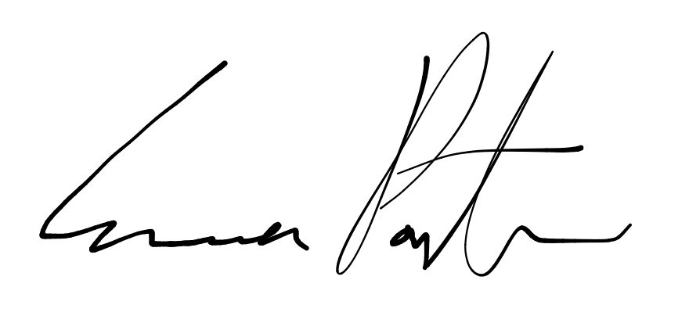

___________________________

**Emma Porter**

President

UBC Music Undergraduate Students’ Association

Respectfully submitted by

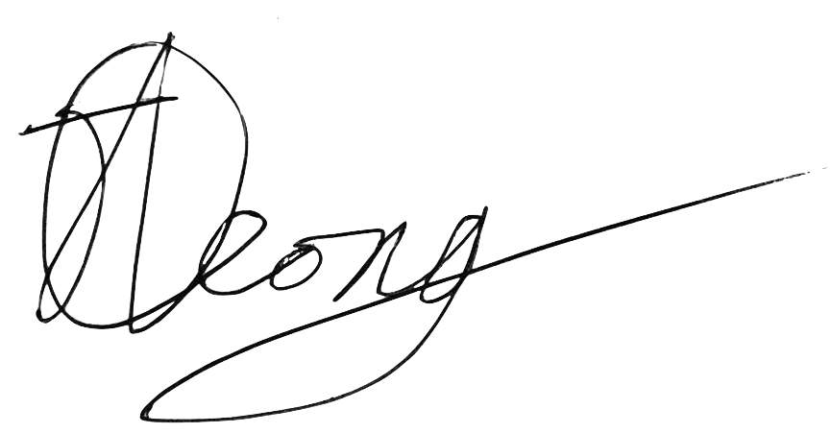

**Jobert Leong**

Vice President of Administration

UBC Music Undergraduate Students’ Association